St. Francis Institute of Technology, Mumbai-400 103

**Department Of Information Technology**

A.Y. 2023-2024

Class: TE-ITA/B, Semester: V

Subject: **DevOps Lab**

**Experiment – 4: To understand Continuous Integration, install and configure Jenkins with Maven/Ant/Gradle to setup a build Job.**

1. **Aim:** To understand Continuous Integration, install and configure Jenkins with Maven
2. **Objectives:** Aim of this experiment is that, the students will be able

* To Integrate and deploy tools like Jenkins and Maven, which is used to build

applications in DevOps environment

1. **Outcomes:** After study of this experiment, the students will be able

* To understand the importance of Jenkins to Build and deploy Software

Applications on server environment.

* Learn about Jenkins (With Architecture)
* To have introduction to Maven / Gradle / Ant

1. **Prerequisite:** Knowledge of software engineering concept of integration
2. **Requirements:** Jenkins,JDK, python, ANT,Personal Computer, Windows operating system, browser, Internet Connection, Microsoft Word.
3. **Pre-Experiment Exercise:**

**Brief Theory:** Refer shared material

1. **Laboratory Exercise**
   * + 1. **Procedure:**

**a. Answer the following:**

* What is Jenkins?
* Why use Jenkins?

**b**. **Execute following (Refer the shared material) and attach screenshots:**

* Install Jenkins
* Configure Jenkins with Maven and ANT
* Build 4 basic projects in Jenkins

1. **Post-Experiments Exercise**
2. **Extended Theory:**

Nil

1. **Questions:**

* What are the system requirements to install Jenkins?
* Give some important plugins in Jenkins.
* What is Maven and ANT?

1. **Conclusion:**

* Write what was performed in the experiment.
* Write the significance of the topic studied in the experiment.

1. **References:**

<https://jenkins.io/doc/>

<https://www.cloudbees.com/jenkins/what-is-jenkins>

<https://vmokshagroup.com/blog/what-is-jenkins/>

<https://www.infoworld.com/article/3239666/what-is-jenkins-the-ci-server-explained.html>

<https://www.edureka.co/blog/interview-questions/jenkins-interview-questions/>

St. Francis Institute of Technology, Mumbai-400 103

**Department Of Information Technology**

A.Y. 2023-2024

Class: TE-ITA/B, Semester: V

Subject: **DevOps Lab**

**Experiment – 4: To understand Continuous Integration, install and configure Jenkins with Maven/Ant/Gradle to setup a build Job**

**List of screenshots to be included in this experiment**

**7b. Execute following (Refer the shared material) and attach screenshots:**

• Install Jenkins

| 1.  2. | 3.  4. |
| --- | --- |

| 5. | 6. |
| --- | --- |
| 7. |  |
| 8. |  |

| 9. |
| --- |
| 10.  11. |
| 12.  13. |

• Configure Jenkins with Maven/Ant/Gradle – Global tool configuration, manage plugins 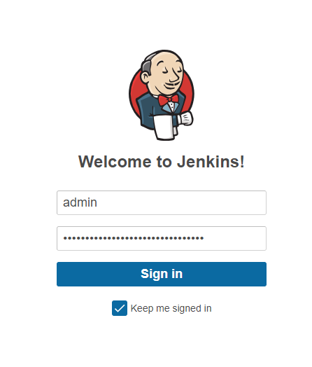

• Build jobs in Jenkins

1. Freestyle project (Simple Windows batch command) – echo

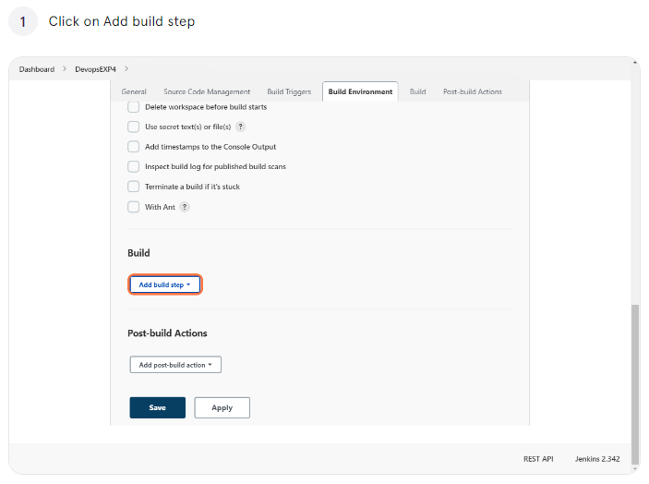

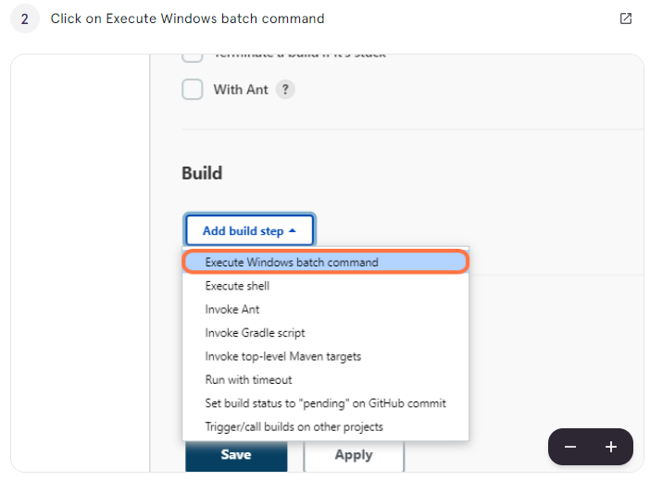

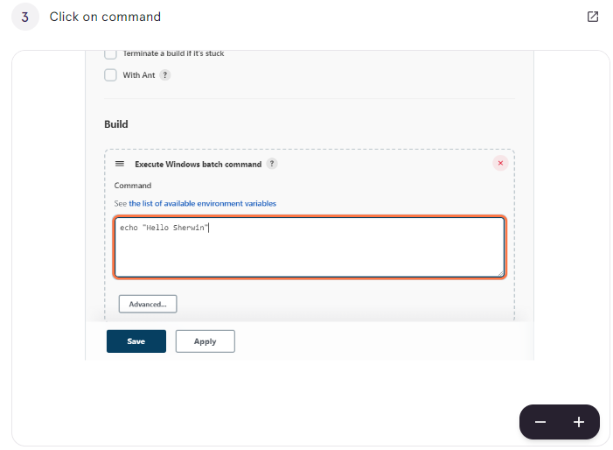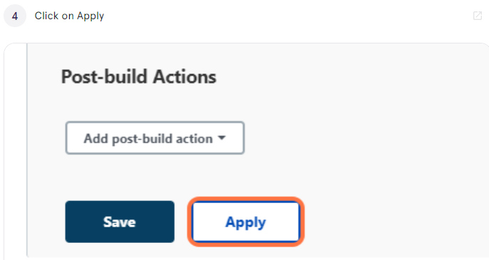

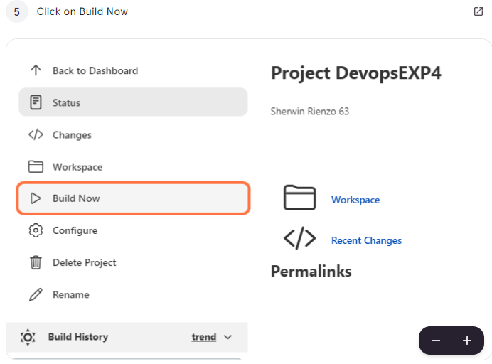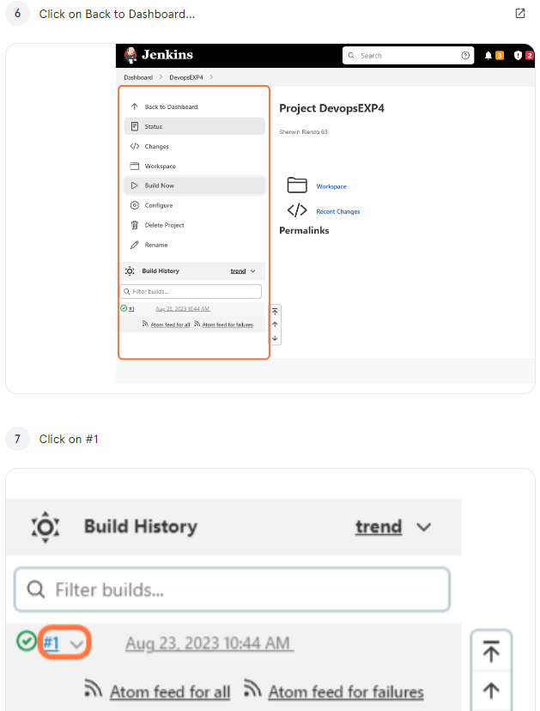

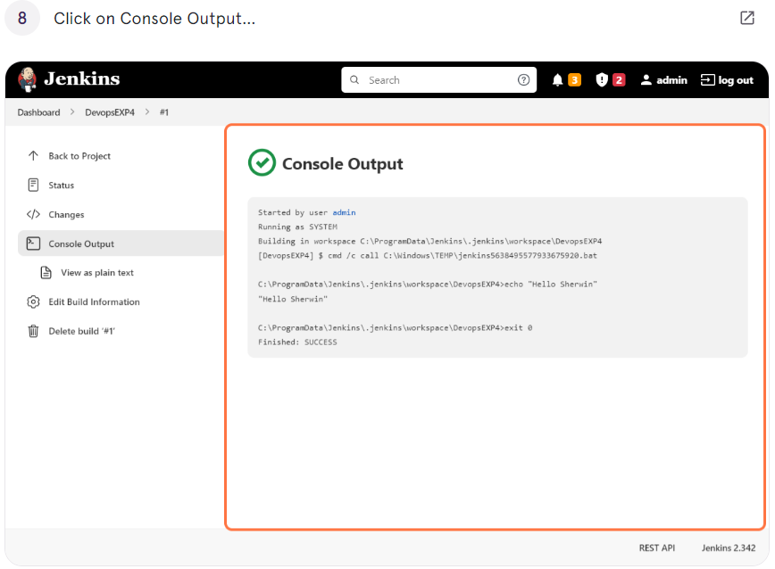

2. Freestyle parameterized project (Windows batch command) string, Boolean and choice parameters with echo

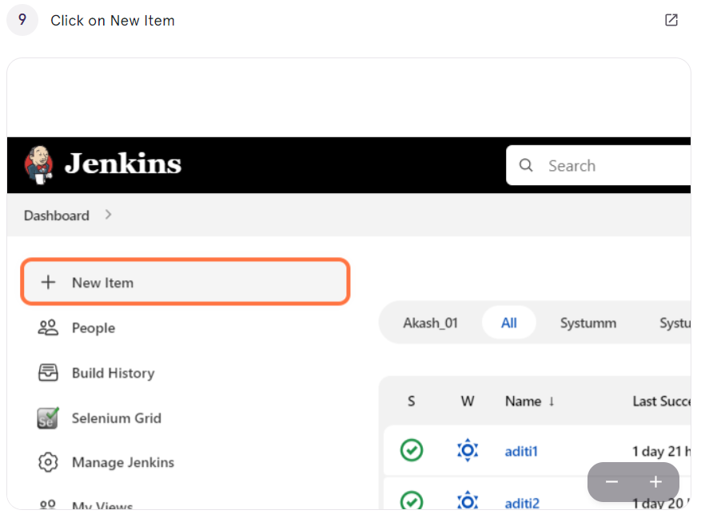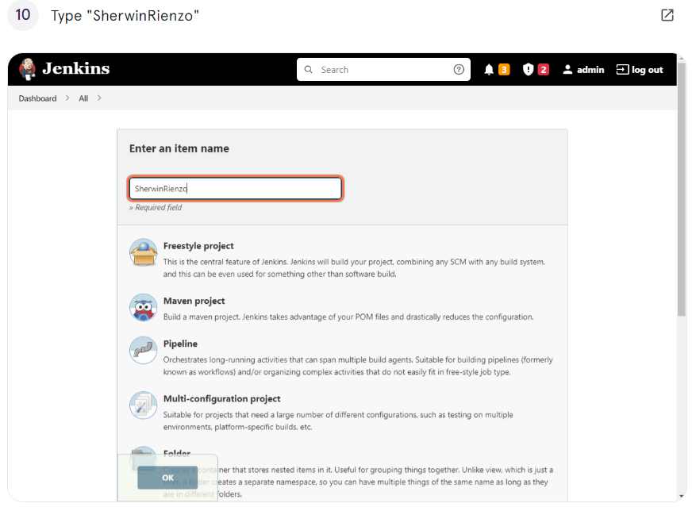

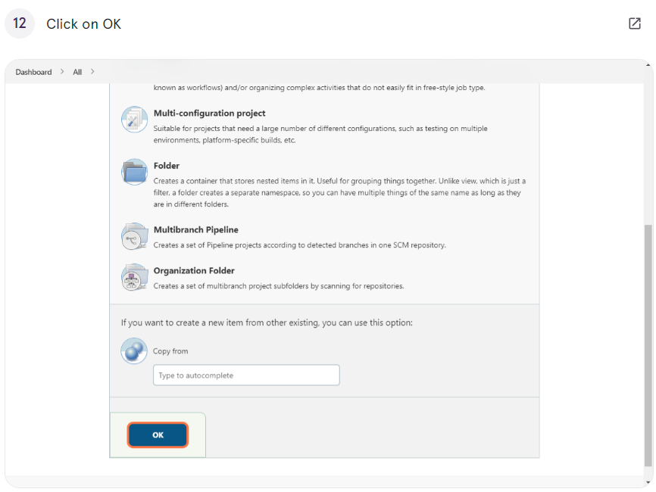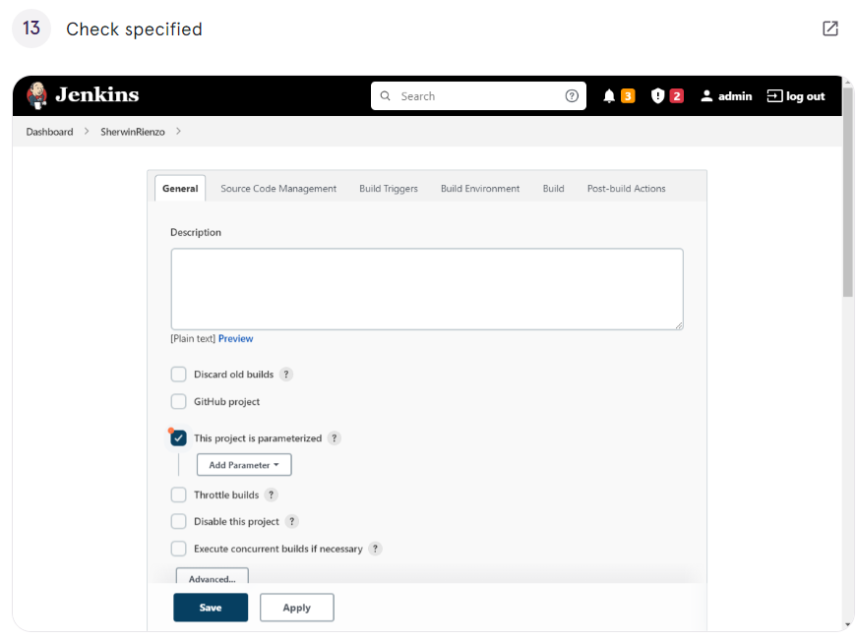

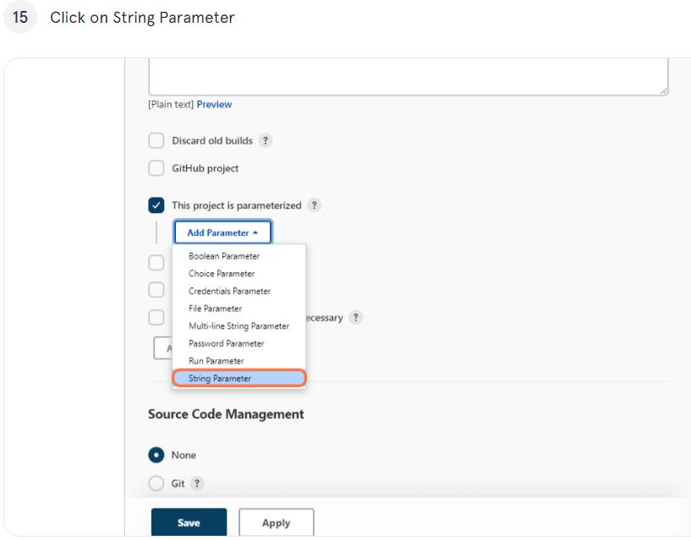



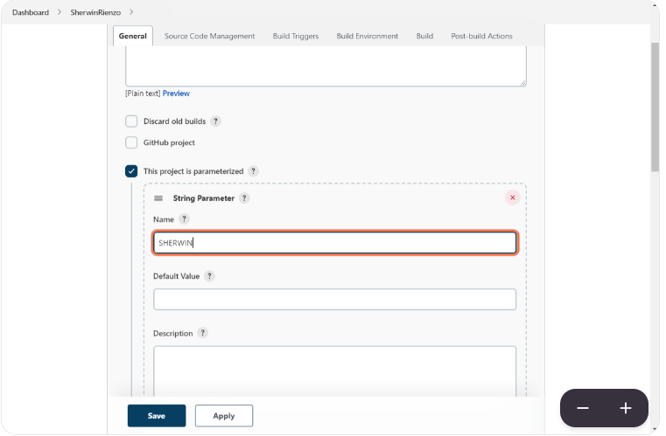

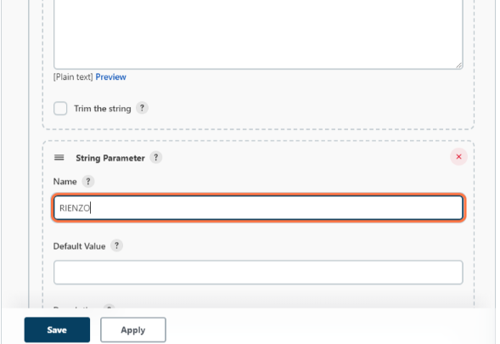

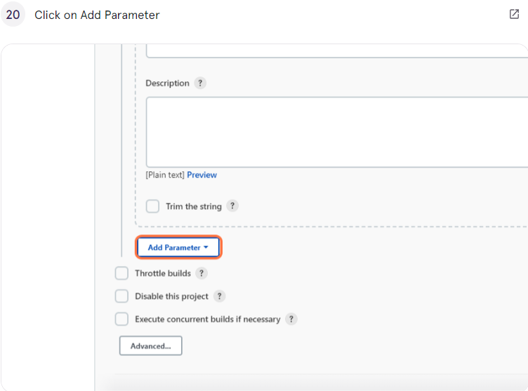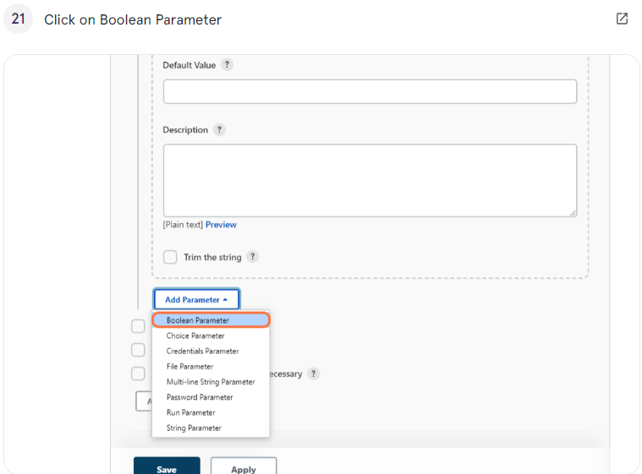

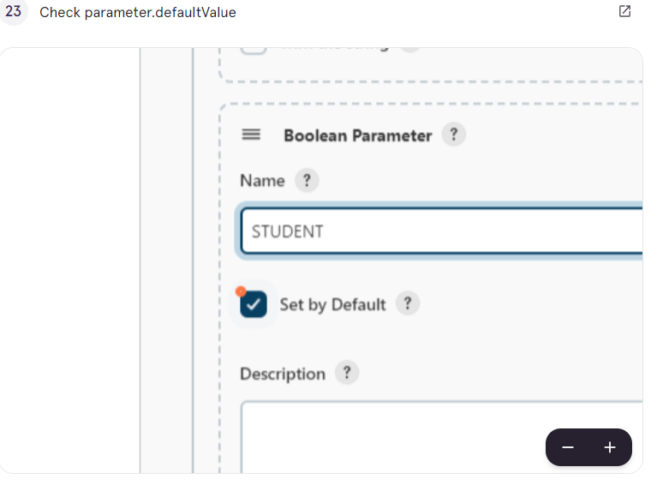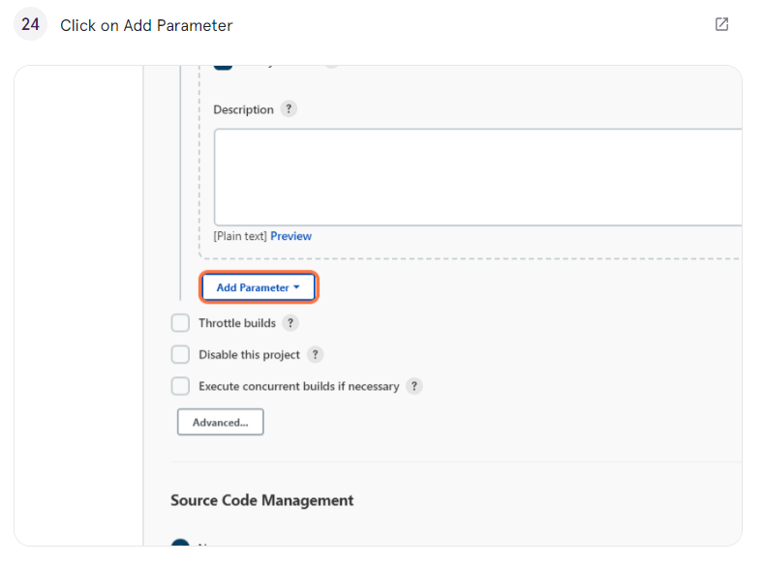

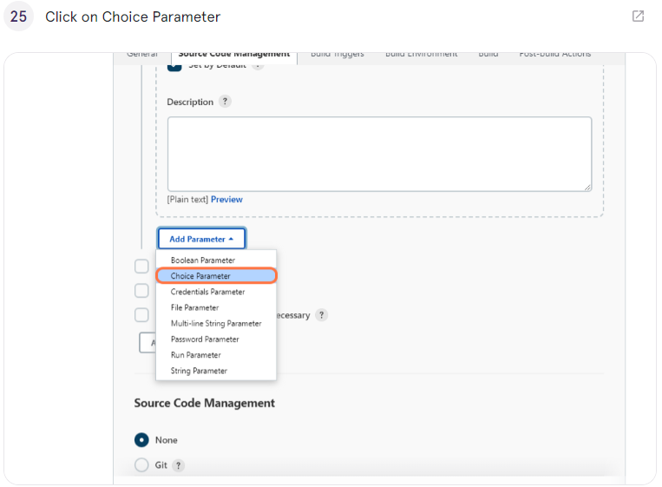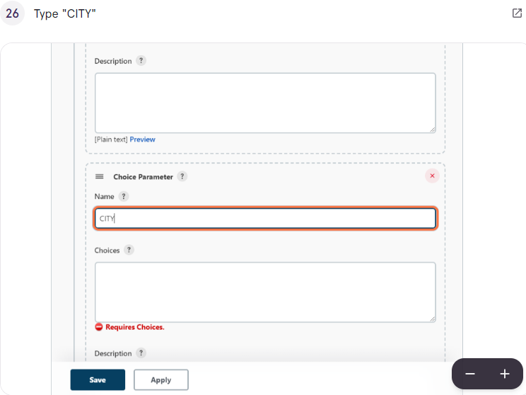

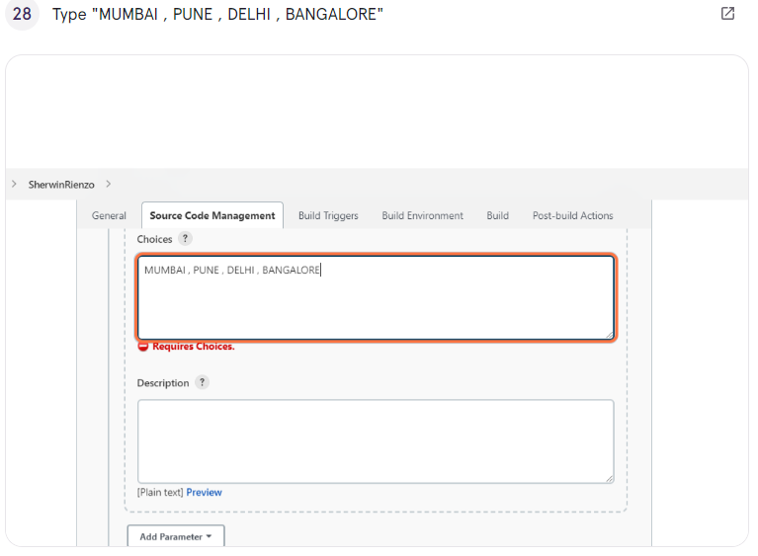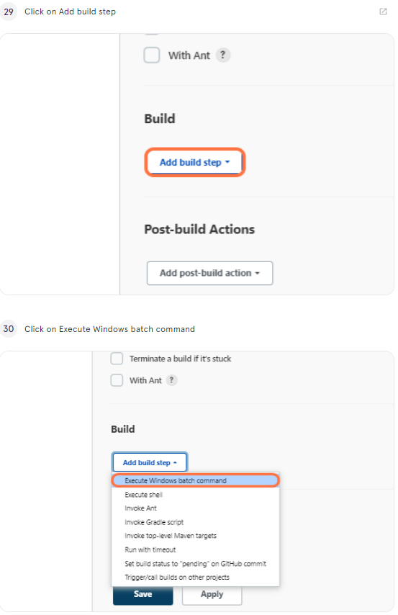

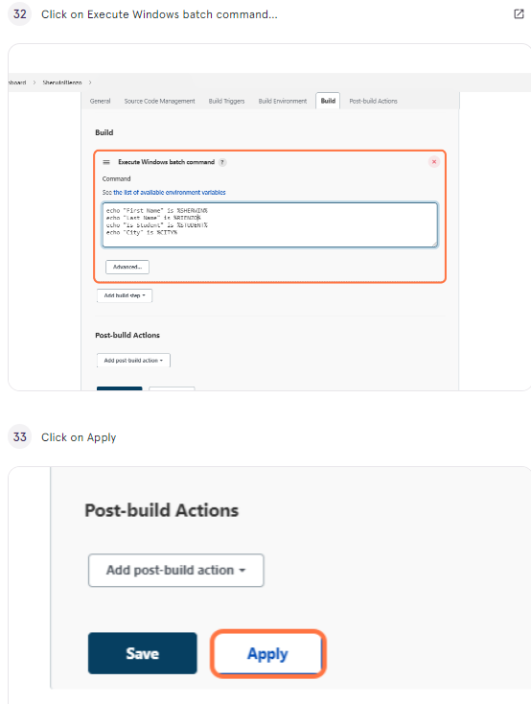

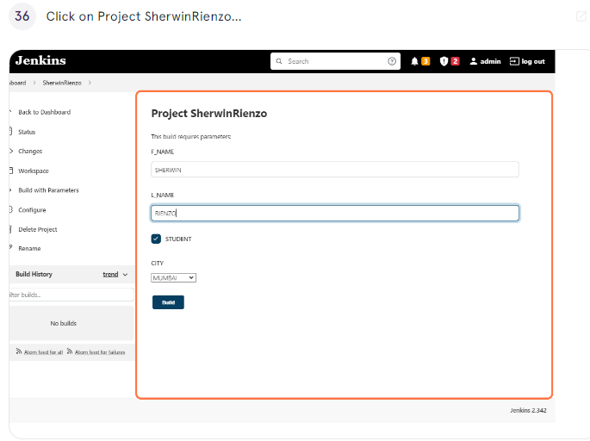

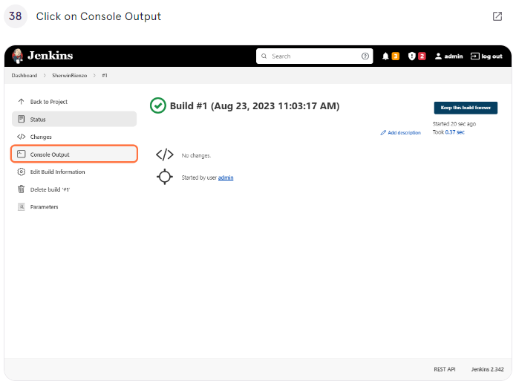

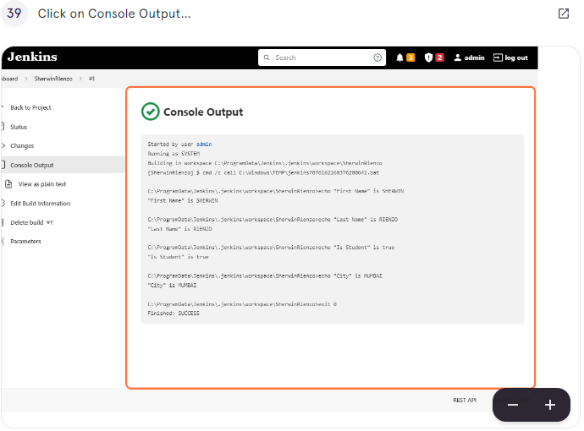

3. Java freestyle project -Hello world

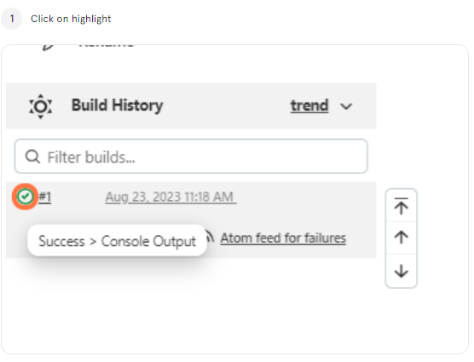

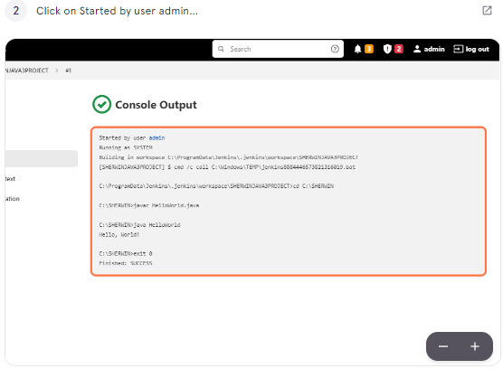

Managing Parameters and Running Windows Batch Commands in Project





